Section 2.)

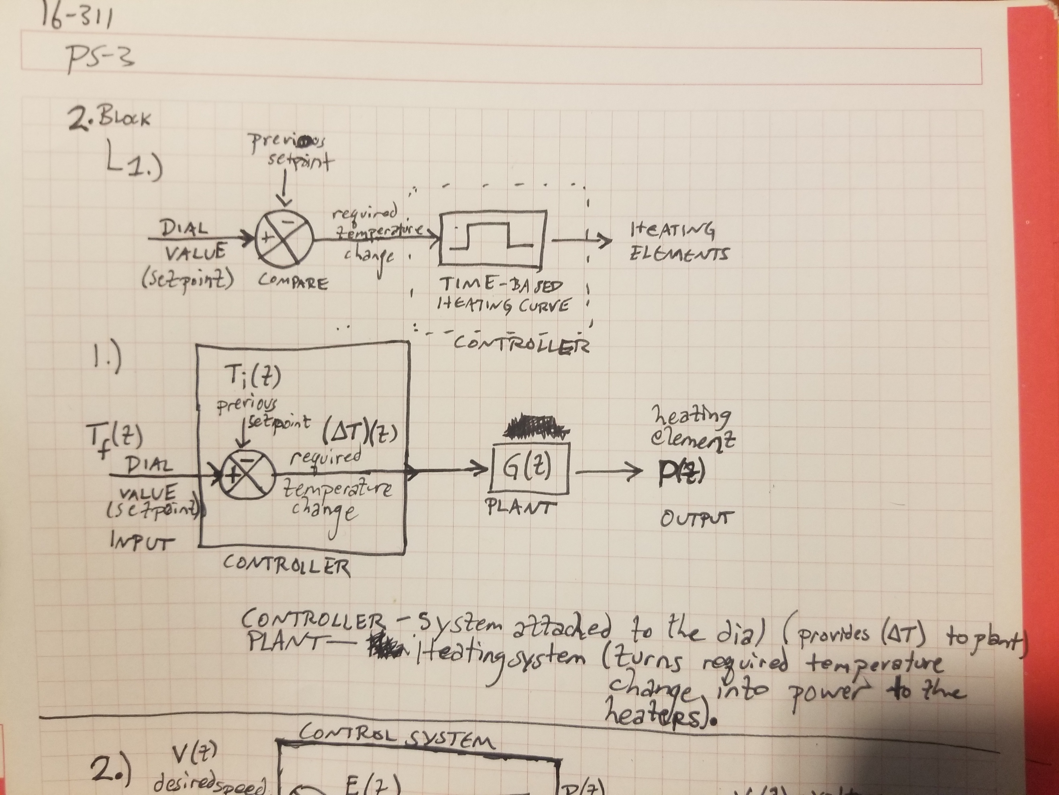

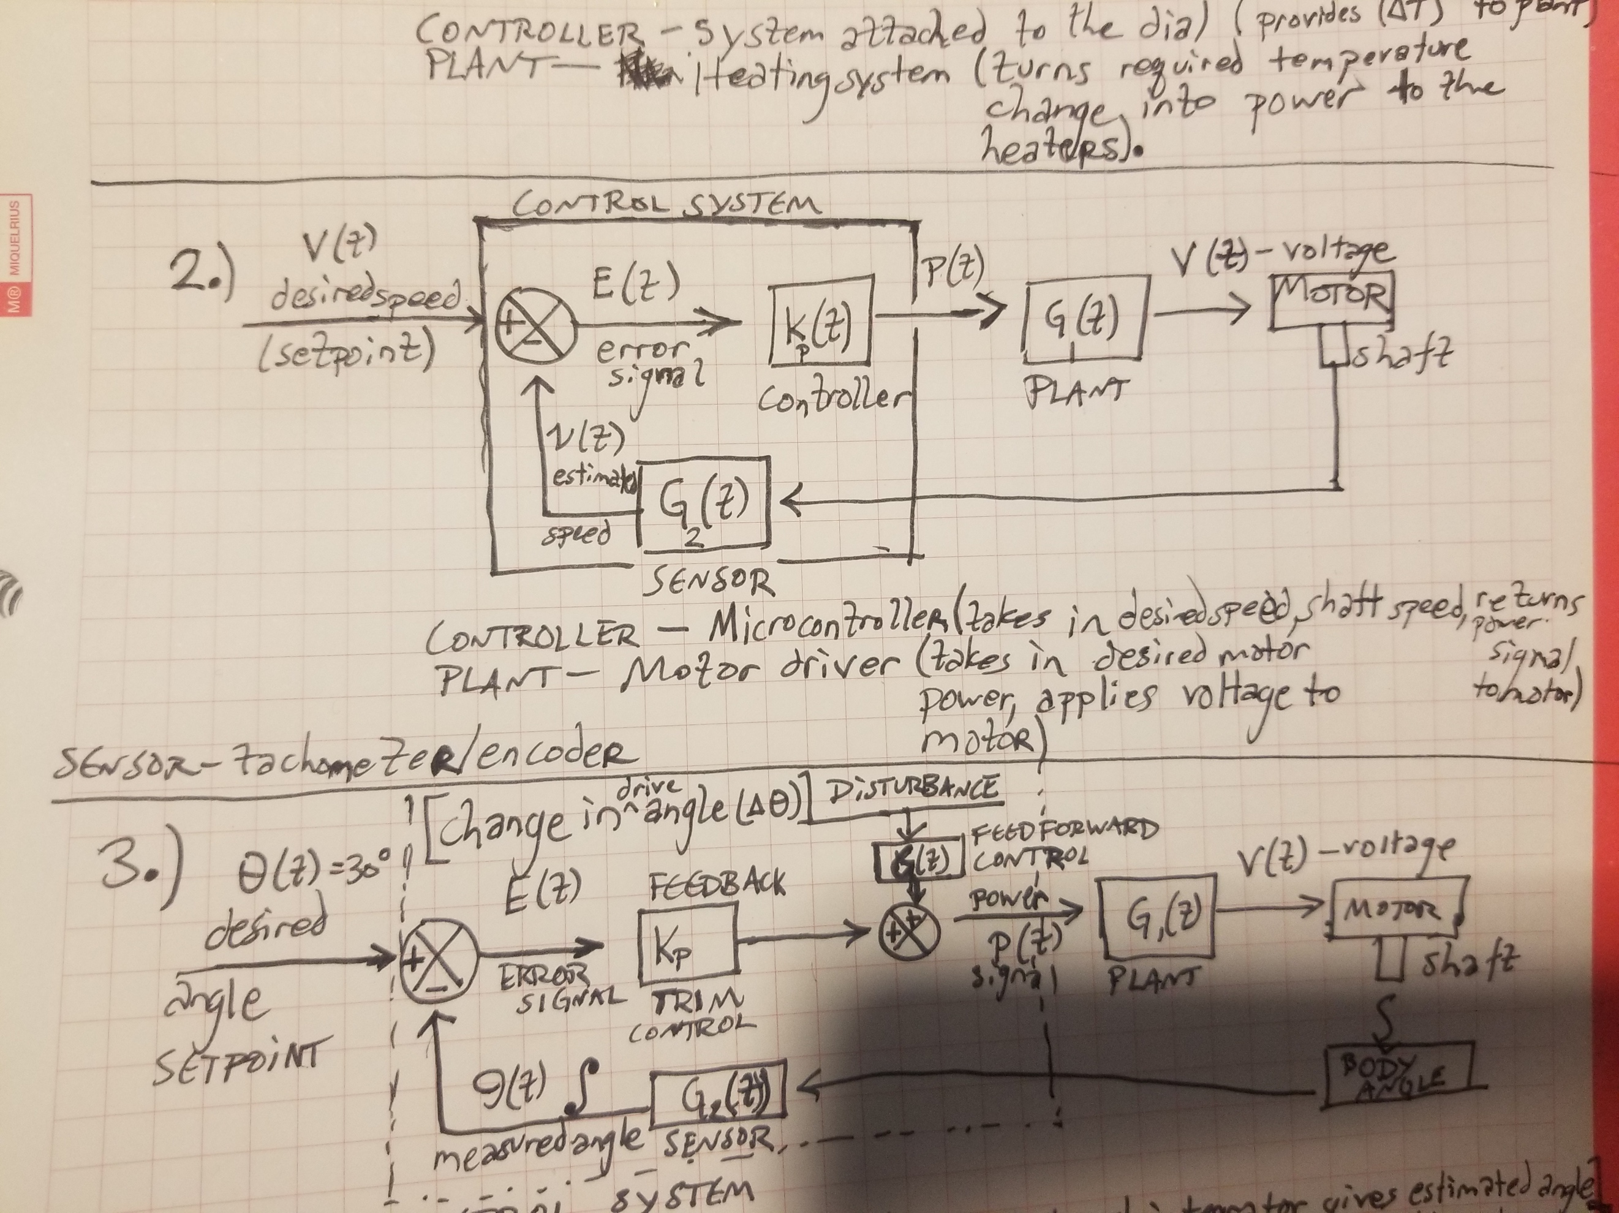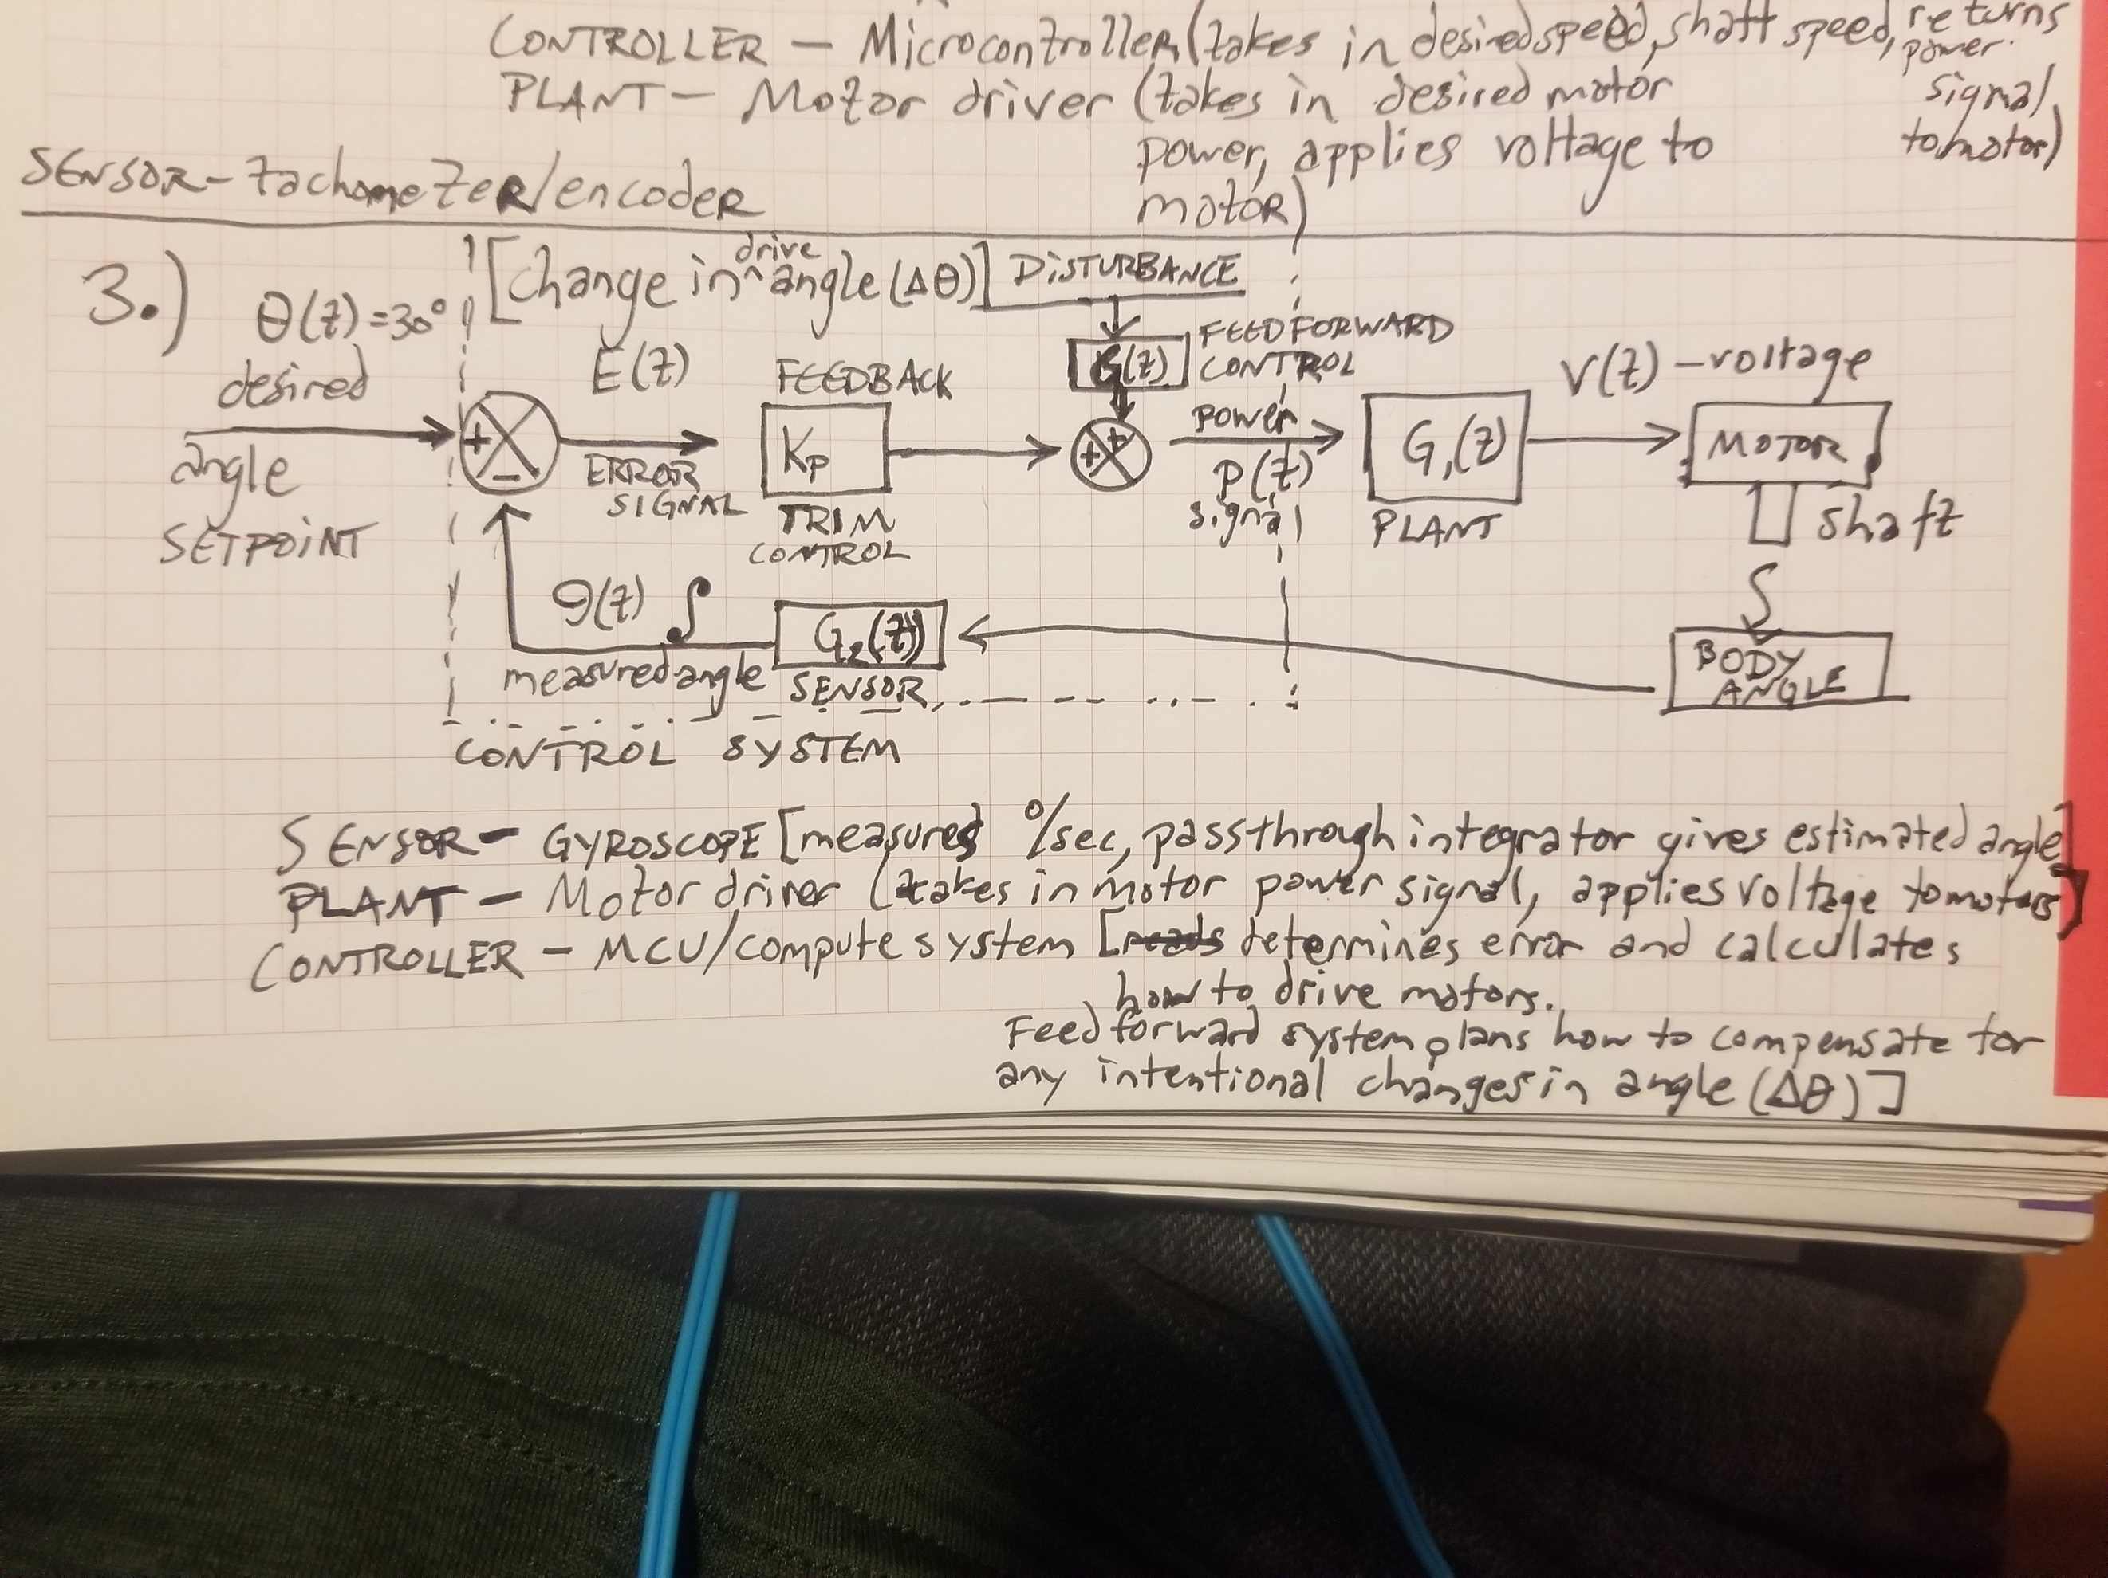

Section 3.)

$$R=1\frac{tick}{deg}, D=5cm$$

$$t_{0}=0s, t_{1}=0.1s$$

$$n_{0}=180 ticks, n_{1}=250 ticks$$

$$C=πD=5π\frac{cm}{rev} \\ ∴E=\frac{C}{R}=\frac{5π\frac{cm}{rev}}{1\frac{tick}{deg}}*\frac{1 rev}{360 deg} \\ →E=\frac{π}{72}\frac{cm}{tick}$$

E is the Distance-to-Encoding Ratio. Therefore, since ticks are discrete, the maximum resolution of distance measurement is $δs=\left(0.5 tick\right)*E=0.022cm$.

$$s=E*\left(Δn\right)=\left(\frac{π}{72}\frac{cm}{tick}\right)*\left(250 ticks-180 ticks\right)$$

$$→s=3.054cm±0.022cm$$

Section 4.)

* If the sensor is unilluminated, moving it closer to the ground would cause the color it reports to be darker since the shadow of the sensor body would occlude more of the ambient light.
* If the sensor is illuminated, bringing it closer to the ground would cause a larger fraction of the light which bounces off the ground and hits the sensor to have originated from the sensor, making the color it reports get brighter, so long as the sensor’s light provides more illumination than is lost by the occlusion of ambient light caused by moving the body closer to the ground. This would also have the effect of causing the color returned to be more consistent as the robot moves through the environment since the provided light source would output the same amount and frequency of light, whereas the characteristics of the ambient light would likely vary with position in the room.
* As such, it would be ideal for an unilluminated sensor to be further from the robot’s body where less of the ambient light would be occluded and the received colors would be brighter and have a wider range; however, for an illuminated sensor (with a powerful enough light-source), it would be ideal for it to be positioned close to the robot where much of the ambient light would be occluded and, as such, most of the light that the sensor collects would come from the more consistent source of illumination provided by the sensor.

Section 5.)

The force equation for this system is:

$$F=ma=kx$$

$$→m\dot{\dot{x}}-kx=0$$

$$→m\left[\frac{dv}{dt}\right]-k\left(∫vdt\right)= 0$$

Assuming the setpoint/controllable parameter is position (not velocity or force):

The force of the spring is proportional to displacement; so, the spring constant, *k*, is analogous to the proportional constant, $K_{p}$.

$$F_{s}=kx \\ ∴K_{p}≅k$$

There is no representation of $K_{d}$ in this system; however, if there were to be a damper which contributes force component $F_{d}=c\dot{x}$, the damper constant, *c*, would be analogous to the differential constant, $K_{d}$.

There is no representation of $K_{i}$ in this system (if the controllable parameter is position; if it were velocity, $K_{i}$ would be k.